**Project Planning Phase**

**Project Planning Template (Product Backlog, Sprint Planning, Stories, Story points)**

|  |  |
| --- | --- |
| Date | 28 June 2025 |
| Team ID | LTVIP2025TMID59203 |
| Project Name | EDUCATIONAL ORGANISATION USING SERVICENOW |
| Maximum Marks |  |

**Product Backlog, Sprint Schedule, and Estimation for Educational Organization** *(4 Marks)*

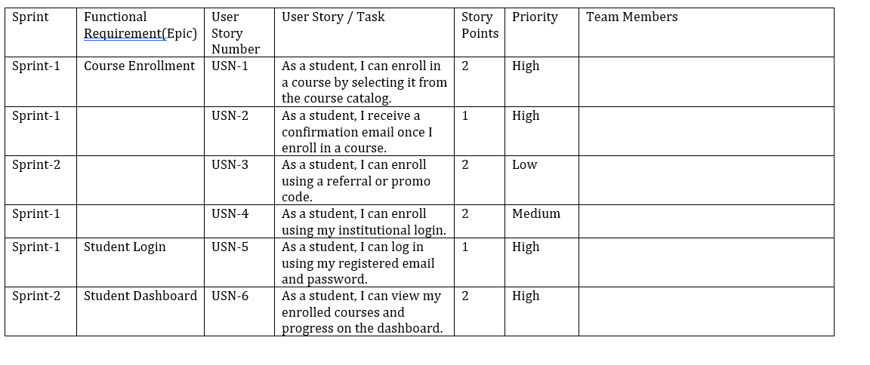

# Educational Organization: Project Tracker, Velocity & Burndown Chart:(4Marks)

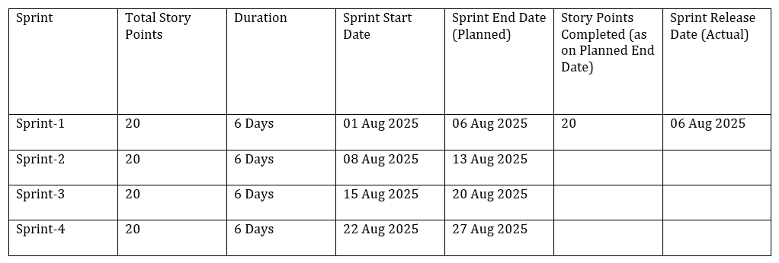

**Velocity:**

Assume we have a 10-day sprint duration, and the velocity of the team is 20 points per sprint. Let’s calculate the team’s average velocity (AV) per iteration unit (story points per day):

AV = velocity ÷ sprint duration = 20 ÷ 10 = 2